Bio-Regen: Working towards zero waste on Maggie
Help us convert unused food into XLR8® Bio (party juice for the microorganisms that make healthy soil), a liquid bio-fertiliser ideal for improving your garden.
Come pick up a MICDA bucket from under the old school house on Dent Street, Horseshoe Bay.
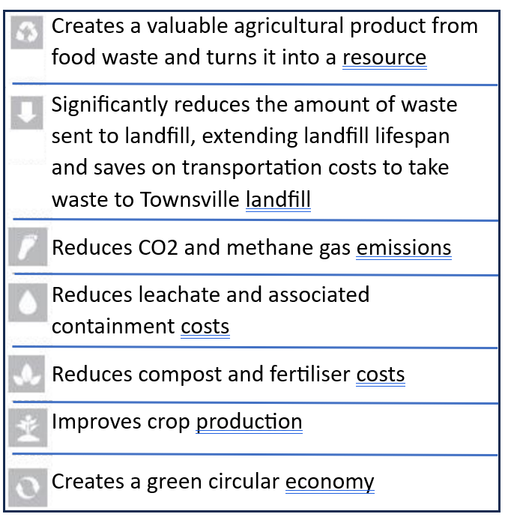
Bring it back with your food scraps Tuesdays and Fridays before 11am and we’ll process it that day.
Once the Bio-regen has chewed 100’s of kilograms of food scraps and it’s stomach (1000 lts IBC) is full, it’s mixed with Xbio Accelerator A & B (specialised formulations used together to balance raw material harvested from the Bio-Regen® process) and completes the assembly of XLR8® Bio.
After it sits for 21 days we’ll be able to give the contributors a litre of this deliciously scented (for the microorganisms) XLR-8® Bio to put on your soil back home.
30 days later we’ll give you another litre and get you to join our citizen science project by reporting back to us on any improvements you’ve seen in your garden.
For more information on what XLR-8® Bio has already been shown to do, visit https://www.vrm.science/products-1
What’s not Ok
avacado seeds
meat bones
corn cobs
What’s Ok
Veggie scraps
fruit including citrus
Seafood and chicken (including bones)
meat
(please freeze meats until day you bring them)

Any enquiries call Annie Taylor 0488321746

